Algorithms questions
The triangle represents a robot, and it follows the code. Where does it end?  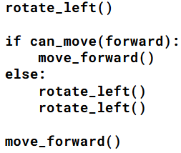  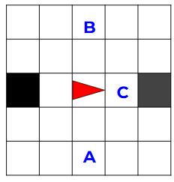 | - Square A  - Square B  - Square C  - It crashes
The triangle represents a robot, and it follows the code. Where does it end?  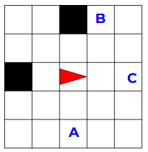 | - Square A  - Square B  - Square C  - It crashes
The triangle represents a robot, and it follows the code. Where does it end?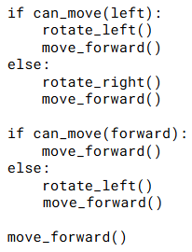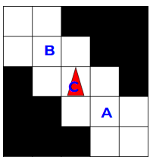 | - Square A  - Square B  - Square C  - It crashes
The triangle represents a robot, and it follows the code. Where does it end?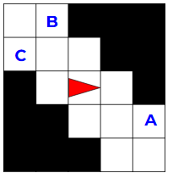 | - Square A  - Square B  - Square C  - It crashes
The triangle represents a robot, and it follows the code. Where does it end?  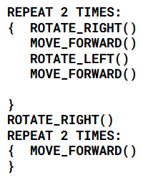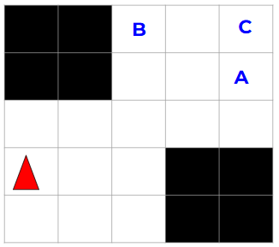 | - Square A  - Square B  - Square C  - It crashes
The triangle represents a robot, and it follows the code. Where does it end?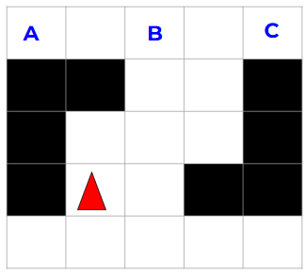 | - Square A  - Square B  - Square C  - It crashes
The triangle represents a robot, and it follows the code. Which corner will it reach first?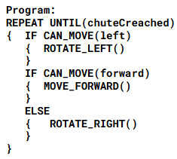  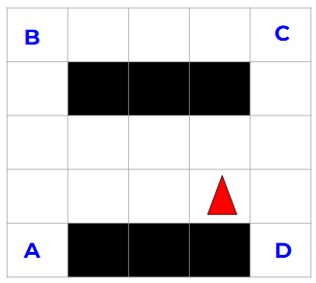 | - Corner A  - Corner B  - Corner C  - Corner D

Binary Applications questions (from AP Classroom)
A store uses binary numbers to assign a unique binary sequence to each item in its inventory. What is the minimum number of bits required for each binary sequence if the store has between 50 and 60 items in its inventory? | - 6 bits  - 7 bits  - 10 bits  - 60 bits
A binary number is to be transformed by appending two 0s to the end of the number. For example, 11101 is transformed to 1110100. Which of the following correctly describes the relationship between the transformed number and the original number? | - The transformed number is 2 times the value of the original number.  - The transformed number is 4 times the value of the original number.  - The transformed number is 8 times the value of the original number.  - The transformed number is 100 times the value of the original number.

From Flowcharts to Code
Use questions from Unit 2 “Design Process and Flowcharts”, and “From Code to Flowcharts”.

